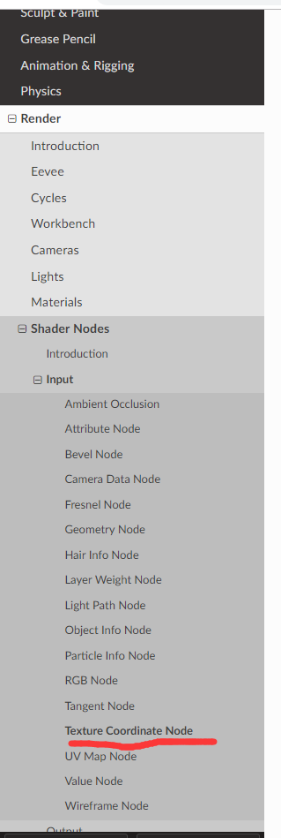
补充本小节和相关小节不清楚的部分
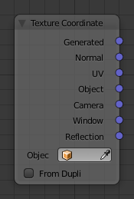

1 property
两个。最下方的object和from dupli
Object
Specific object to use for object space coordinates. This only affects the Object output.
用法暂时不知道

From dupli
Cycles Only
If the object is generated by instancing from vertices or faces, use texture coordinates from instancer. This only affects the Generated and UV outputs
From Instancer only works with the UV output when the object is instanced, either from particles or from faces.
关于instancing from faces，

又称为DupliFaces
Reference
Mode: | Object Mode
Panel: | Object ‣ Duplication
Menu: | Object ‣ Make Dupli-Face
效果，要有parent，基于parent的面复制child

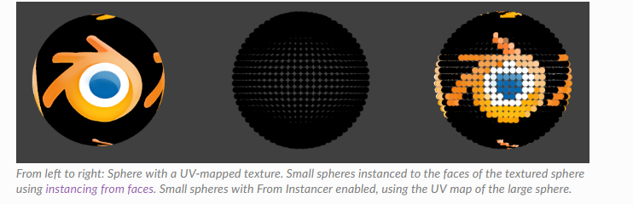
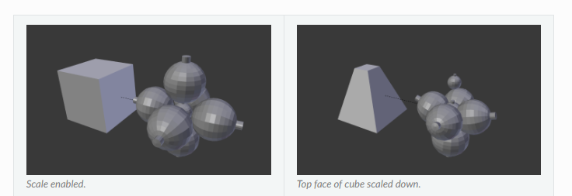
具体见本节的链接

